

**BREAST CANCER PREDICTION**

API Documentation



August 17, 2021

Women TECHSTERS

Lagos, Nigeria

# API DOCUMENTATION

1. **INTRODUCTION**

API is the acronym for Application Programming Interface, which is a software intermediary that allows two applications to talk to each other. In most cases APIs are used to return data in a standard data-exchange format. In machine learning APIs are created when a model is deployed and hosted in a cloud or web server. The API is therefore linked to a website or an application.

**The breast cancer API is used in:**

User Modelling – To make predictions about a patient’s breast cancer status based on characteristics given from the doctor’s input.

API End point url : [Link to API](https://acesbc.herokuapp.com/)

## 

## METHODOLOGY

## 

The API was developed using flask a web services’ framework in python.

Then pushed to the GitHub repository.

We used HEROKU to host the flask application.

## API USAGE

The API is compatible with any backend programming languages. The API was consumed to the backend of our website. This API is the end point needed to be consumed when one wants to send data and receive response from the random forest classifier model.

Ace breast cancer prediction API connects you to the model you need to build an innovative website or app for predicting a patient’s breast cancer status.

Allows you to build tools that aid in decreasing the chances of a patient getting misdiagnosed when it comes to breast cancer.

The figure below represents the Flask App code:

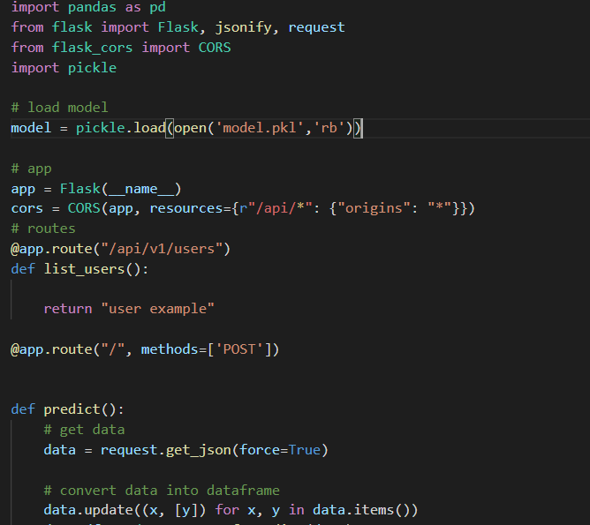

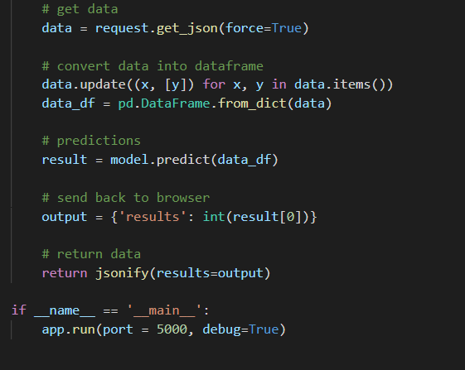

The figure below represents how you test if the API is working:

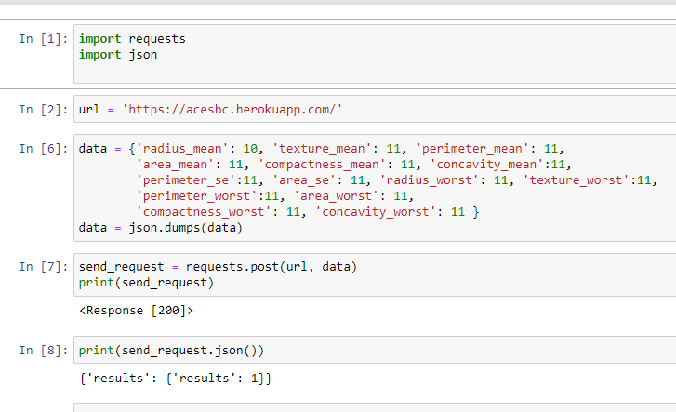

## REFERENCES

1. https://towardsdatascience.com/create-an-api-to-deploy-machine-learning-models-using-flask-and-heroku-67a011800c50